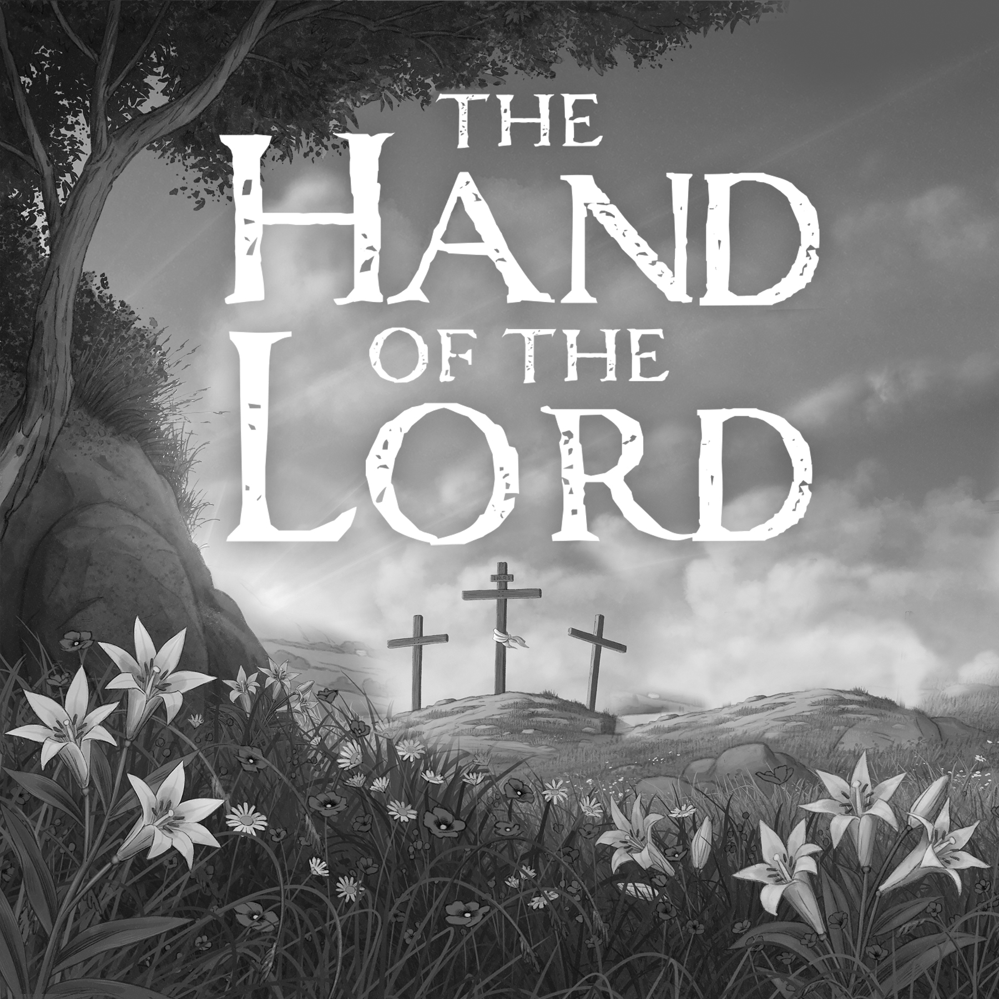

St.

Matthew Lutheran Church

Hazen, ND

Lenten Vespers

Wednesday, April 9, 2025

Pastor Peters

The Hand of the Lord Who Holds All Things

To the faithless, unrepentant world, taken together with the climax of the events of Holy Week, it appears that, after all, Jesus ends up only a disappointment, dead and gone! To the eyes of faith, however, all His deeds, including His suffering and death, describe the most powerful and mighty act of God, by which He redeems and saves the world and us!

The Christian liturgy preserves certain words in their original language to express their full meaning. For instance, we do not end prayers saying, “Yes, yes, it shall be so,” but the original “Amen.” Likewise, every Sunday we sing the Sanctus, “Holy, Holy, Holy Lord God of Sabaoth.” *Tsebaot* in Hebrew means “hosts” or “armies.” “Lord God of hosts” is a way of saying God is over all—all powerful. So also, Greek art depicts the risen, ascended, and reigning Lord Jesus as *Pantokrator*, “the Almighty!” The church has always claimed that, before and after all, Jesus Christ indeed holds all things. By faith in Jesus, we know that we are forgiven, renewed, redeemed, and destined for eternal glory.

Opening Sentences

P O Lord, open my lips,

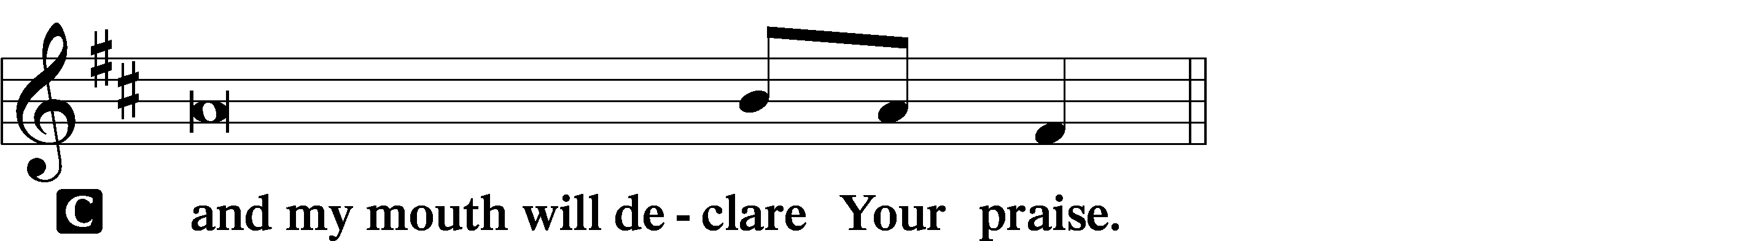

P Make haste, O God, to deliver me;

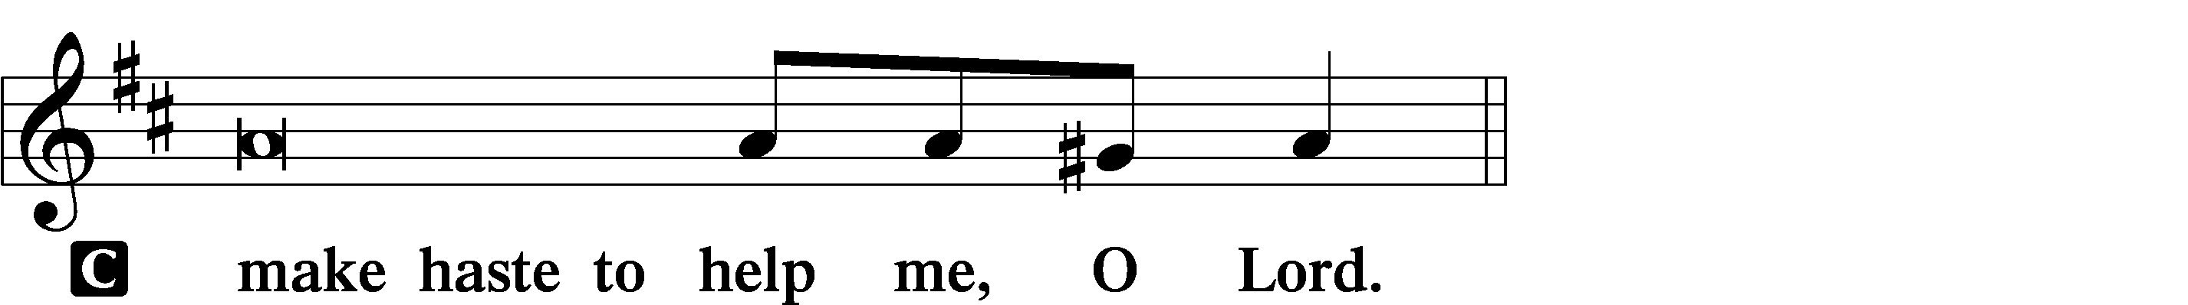

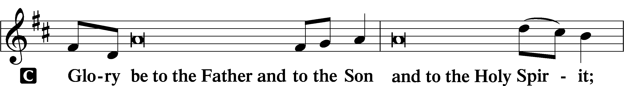

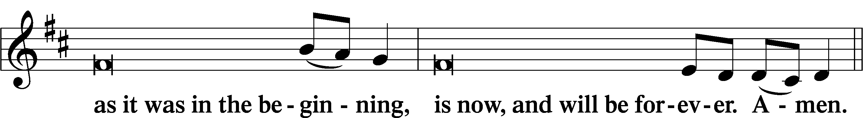

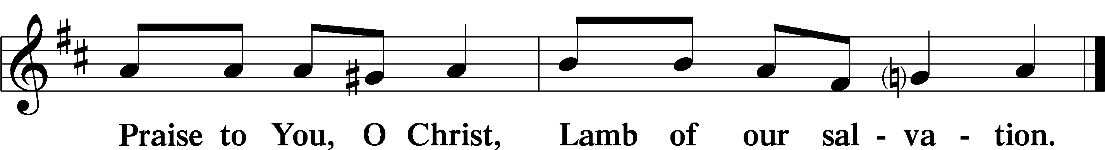

# Psalmody

Psalm Psalm 95:1–7a

L Oh come, let us sing to the Lord;  
let us make a joyful noise to the rock of our salvation!

C **Let us come into His presence with thanksgiving;**  
 **let us make a joyful noise to Him with songs of praise!**  
**For the Lord is a great God,**  
 **and a great King above all gods.**  
**In His hand are the depths of the earth;**  
 **the heights of the mountains are His also.**  
**The sea is His, for He made it,**  
 **and His hands formed the dry land.**  
**Oh come, let us worship and bow down;**  
 **let us kneel before the Lord, our Maker!**  
**For He is our God,**  
 **and we are the people of His pasture,**  
 **and the sheep of His hand.**

The Word That Spoke in Darkness

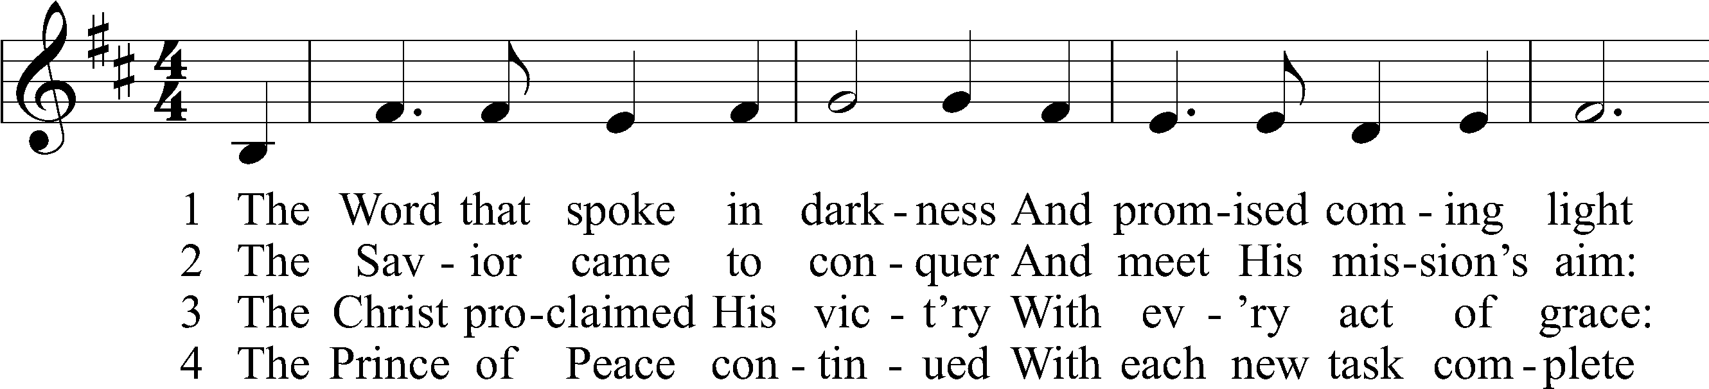

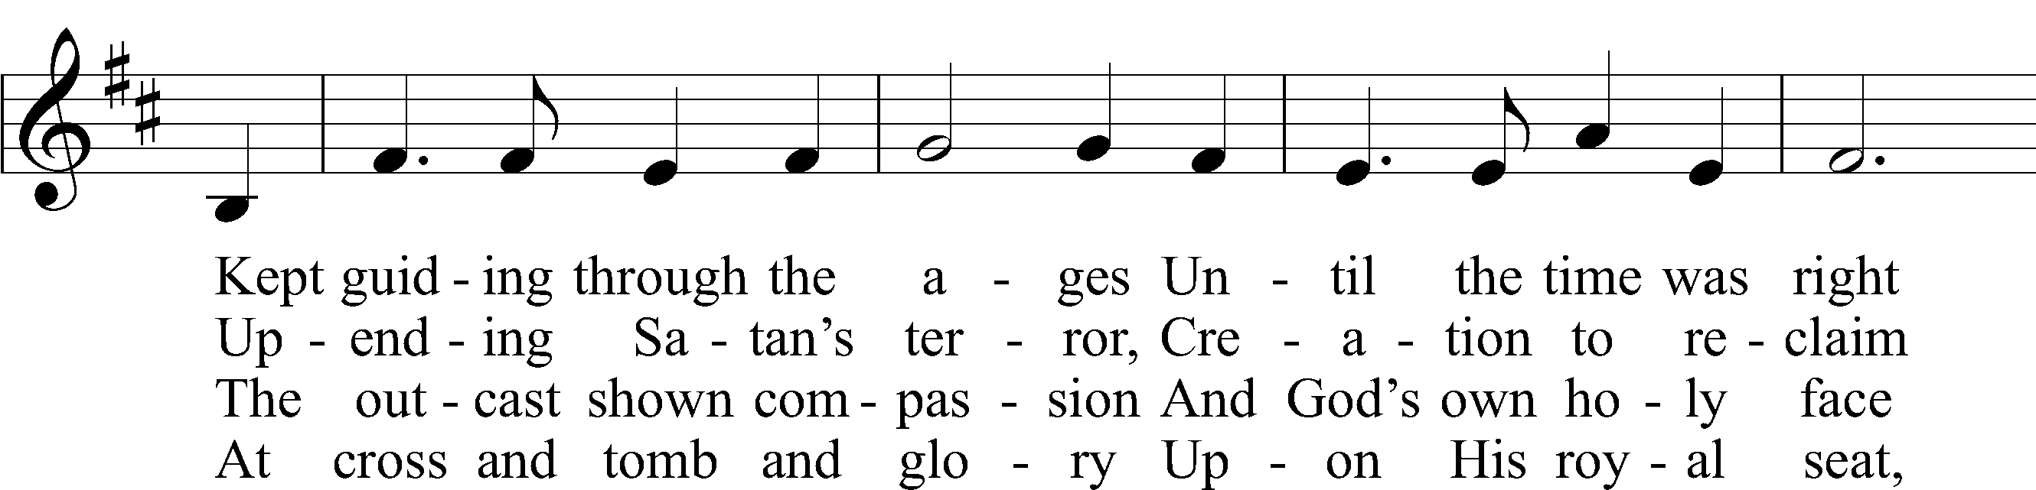

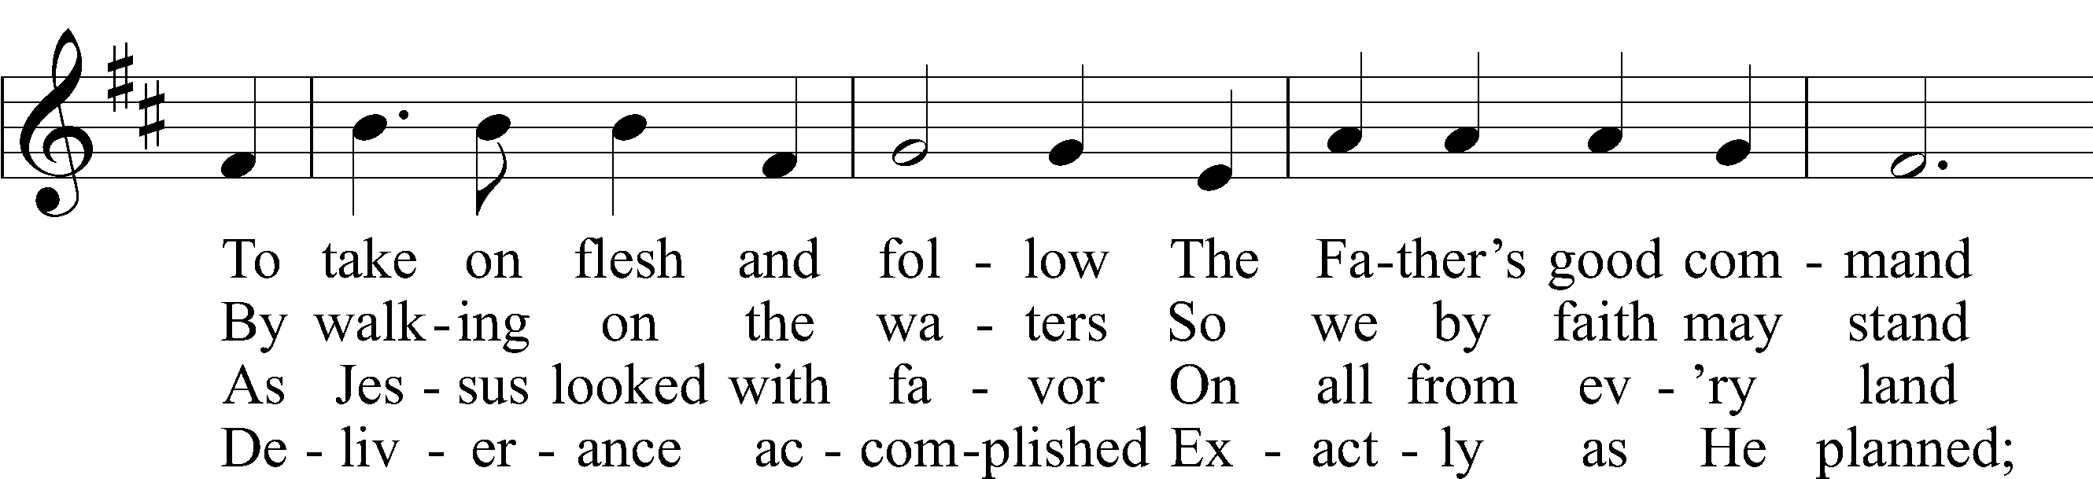

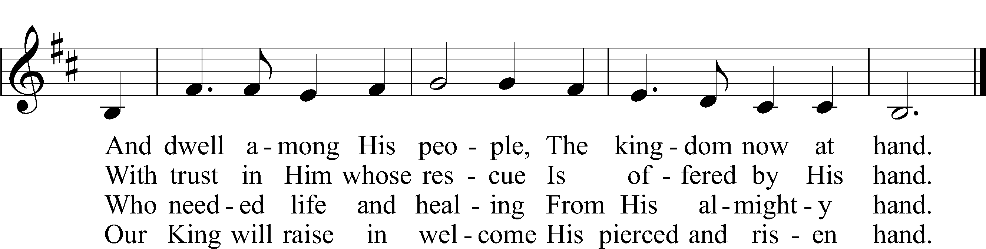

Text: Lisa M. Clark  
Tune: Mark Knickelbein  
Text: © 2024 Concordia Publishing House. Used by permission: CPH Lent License no. 110004310  
Tune: © 2024 Concordia Publishing House. Used by permission: CPH Lent License no. 110004310

# Readings

Reading Daniel 7:13–14

13I saw in the night visions,

and behold, with the clouds of heaven  
 there came one like a son of man,  
and he came to the Ancient of Days  
 and was presented before him.  
14And to him was given dominion  
 and glory and a kingdom,  
that all peoples, nations, and languages  
 should serve him;  
his dominion is an everlasting dominion,  
 which shall not pass away,  
and his kingdom one  
 that shall not be destroyed.

P This is the Word of the Lord.

C **Thanks be to God.**

Reading Revelation 1:9–20

9I, John, your brother and partner in the tribulation and the kingdom and the patient endurance that are in Jesus, was on the island called Patmos on account of the word of God and the testimony of Jesus. 10I was in the Spirit on the Lord’s day, and I heard behind me a loud voice like a trumpet 11saying, “Write what you see in a book and send it to the seven churches, to Ephesus and to Smyrna and to Pergamum and to Thyatira and to Sardis and to Philadelphia and to Laodicea.”

12Then I turned to see the voice that was speaking to me, and on turning I saw seven golden lampstands, 13and in the midst of the lampstands one like a son of man, clothed with a long robe and with a golden sash around his chest. 14The hairs of his head were white like wool, as white as snow. His eyes were like a flame of fire, 15his feet were like burnished bronze, refined in a furnace, and his voice was like the roar of many waters. 16In his right hand he held seven stars, from his mouth came a sharp two-edged sword, and his face was like the sun shining in full strength.

17When I saw him, I fell at his feet as though dead. But he laid his right hand on me, saying, “Fear not, I am the first and the last, 18and the living one. I died, and behold I am alive forevermore, and I have the keys of Death and Hades. 19Write therefore the things that you have seen, those that are and those that are to take place after this. 20As for the mystery of the seven stars that you saw in my right hand, and the seven golden lampstands, the seven stars are the angels of the seven churches, and the seven lampstands are the seven churches.

P This is the Word of the Lord.

C **Thanks be to God.**

Reading John 3:11–18, 22–36

11Truly, truly, I say to you, we speak of what we know, and bear witness to what we have seen, but you do not receive our testimony. 12If I have told you earthly things and you do not believe, how can you believe if I tell you heavenly things? 13No one has ascended into heaven except he who descended from heaven, the Son of Man. 14And as Moses lifted up the serpent in the wilderness, so must the Son of Man be lifted up, 15that whoever believes in him may have eternal life.

16“For God so loved the world, that he gave his only Son, that whoever believes in him should not perish but have eternal life. 17For God did not send his Son into the world to condemn the world, but in order that the world might be saved through him. 18Whoever believes in him is not condemned, but whoever does not believe is condemned already, because he has not believed in the name of the only Son of God.

22After this Jesus and his disciples went into the Judean countryside, and he remained there with them and was baptizing. 23John also was baptizing at Aenon near Salim, because water was plentiful there, and people were coming and being baptized 24(for John had not yet been put in prison).

25Now a discussion arose between some of John’s disciples and a Jew over purification. 26And they came to John and said to him, “Rabbi, he who was with you across the Jordan, to whom you bore witness—look, he is baptizing, and all are going to him.” 27John answered, “A person cannot receive even one thing unless it is given him from heaven. 28You yourselves bear me witness, that I said, ‘I am not the Christ, but I have been sent before him.’ 29The one who has the bride is the bridegroom. The friend of the bridegroom, who stands and hears him, rejoices greatly at the bridegroom’s voice. Therefore this joy of mine is now complete. 30He must increase, but I must decrease.”

31He who comes from above is above all. He who is of the earth belongs to the earth and speaks in an earthly way. He who comes from heaven is above all. 32He bears witness to what he has seen and heard, yet no one receives his testimony. 33Whoever receives his testimony sets his seal to this, that God is true. 34For he whom God has sent utters the words of God, for he gives the Spirit without measure. 35The Father loves the Son and has given all things into his hand. 36Whoever believes in the Son has eternal life; whoever does not obey the Son shall not see life, but the wrath of God remains on him.

P This is the Word of the Lord.

C **Thanks be to God.**

Lent Responsory LSB 231

P Deliver me, O Lord, my God, for You are the God of my salvation.

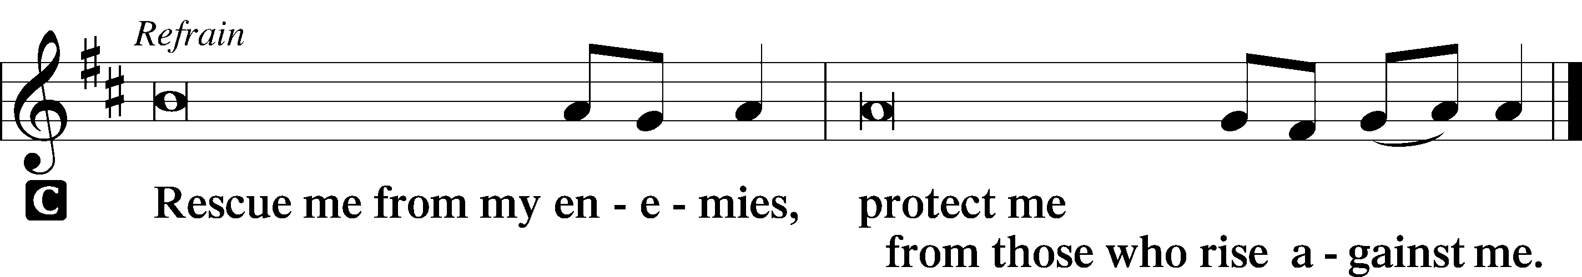

P In You, O Lord, do I put my trust, leave me not, O Lord, my God.



P Deliver me, O Lord, my God, for You are the God of my salvation.



802 Immortal, Invisible, God Only Wise

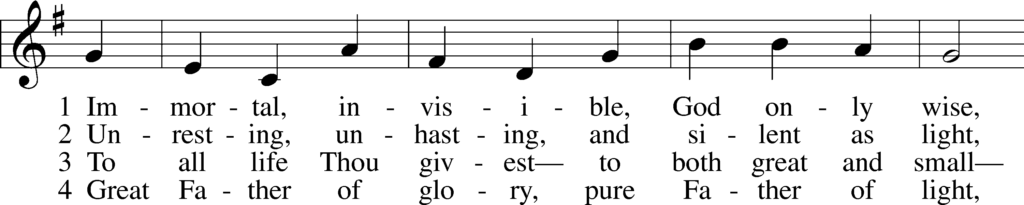

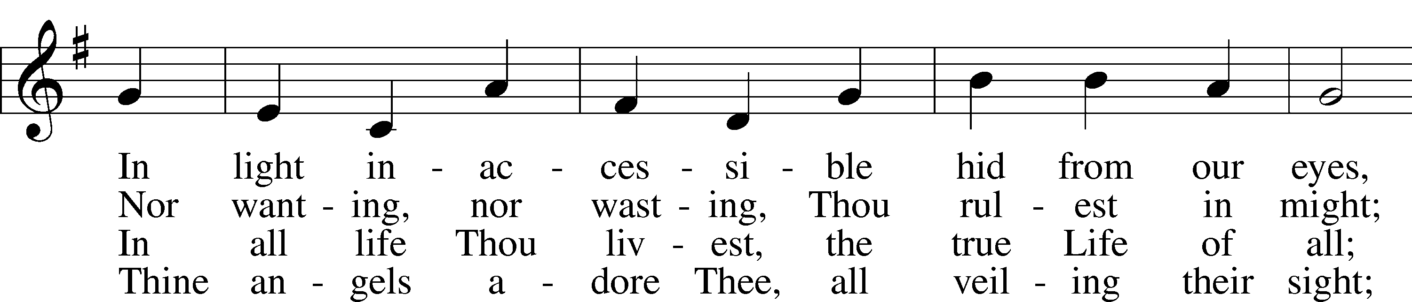

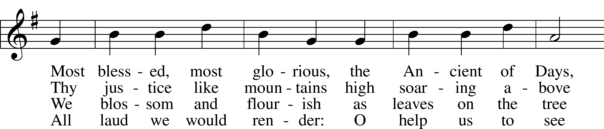

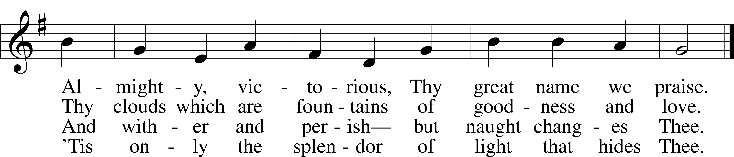

Text: W. Chalmers Smith, 1824–1908, alt.  
Tune: Welsh  
Text and tune: Public domain

Sermon

# Canticle

Antiphon LSB 231

P Let my prayer rise before You as incense,

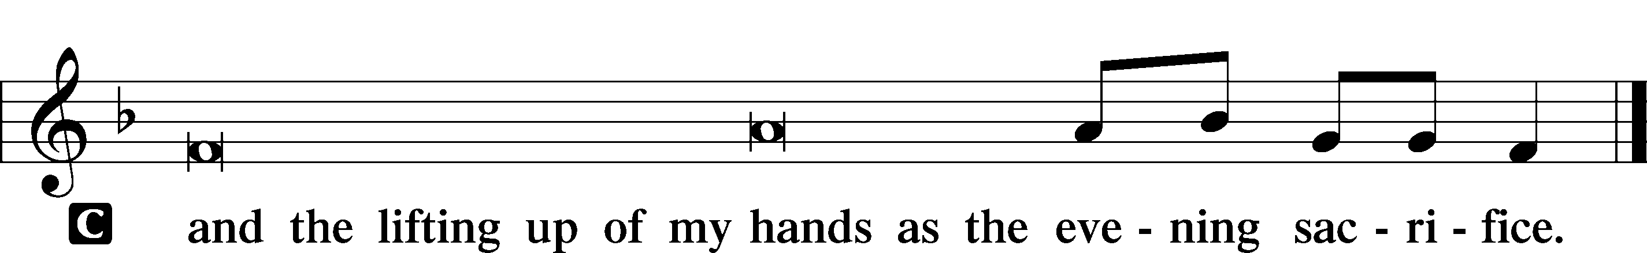

Magnificat LSB 231

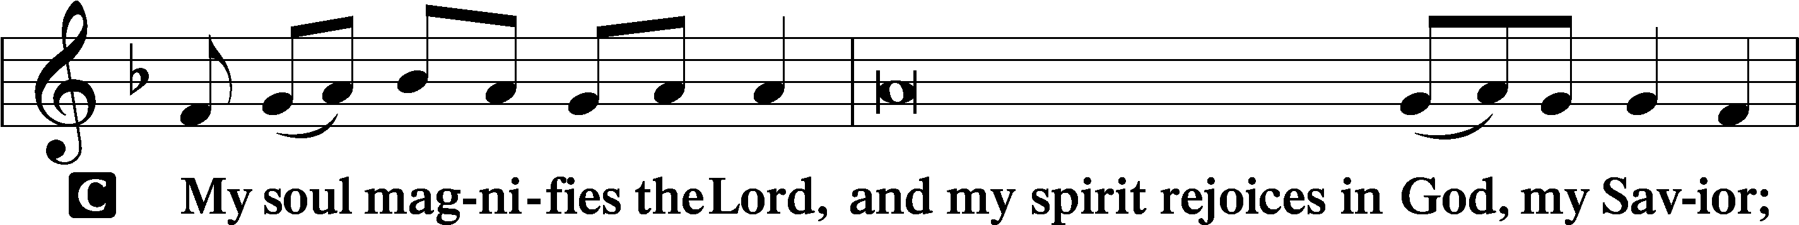

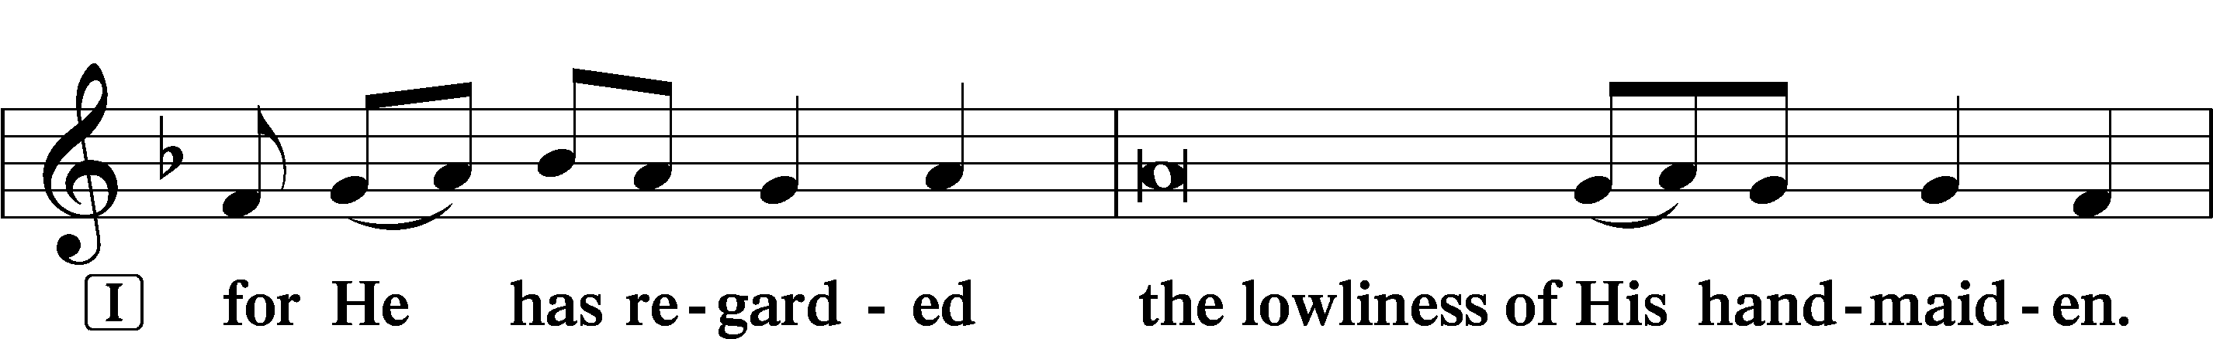

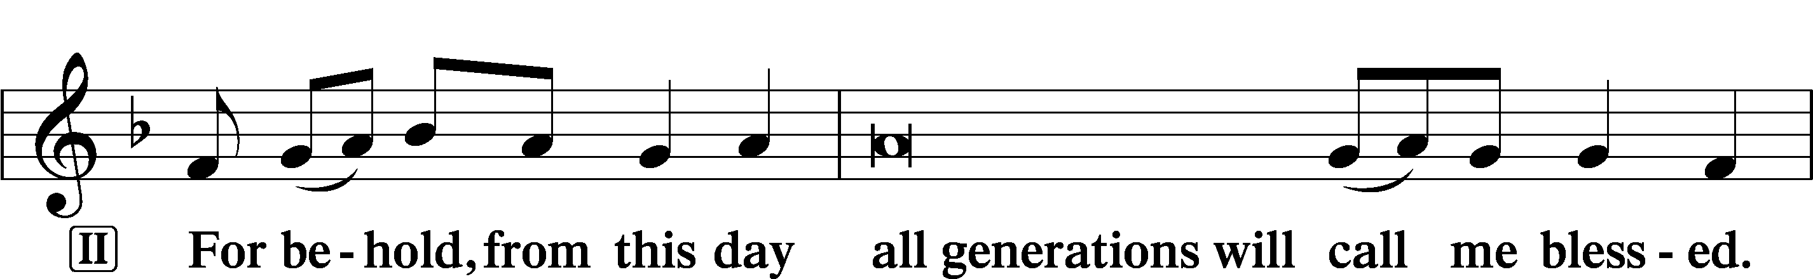

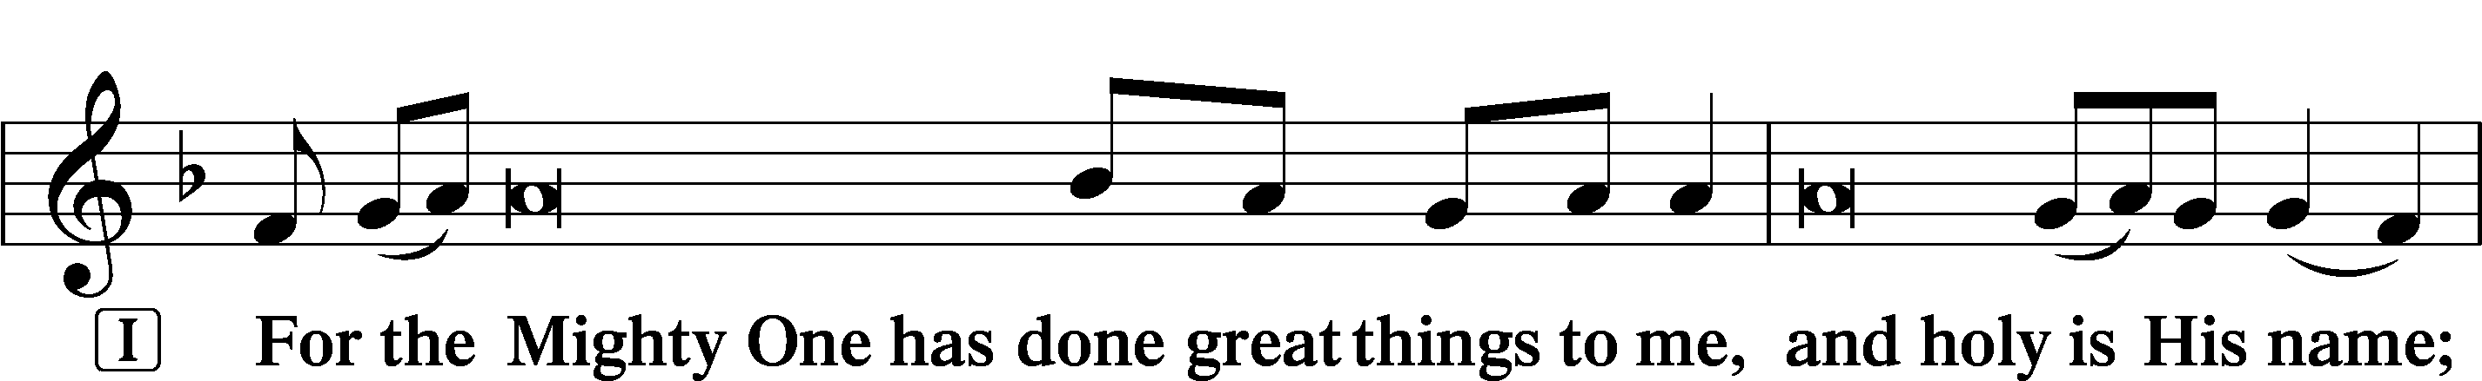

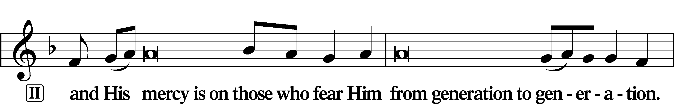

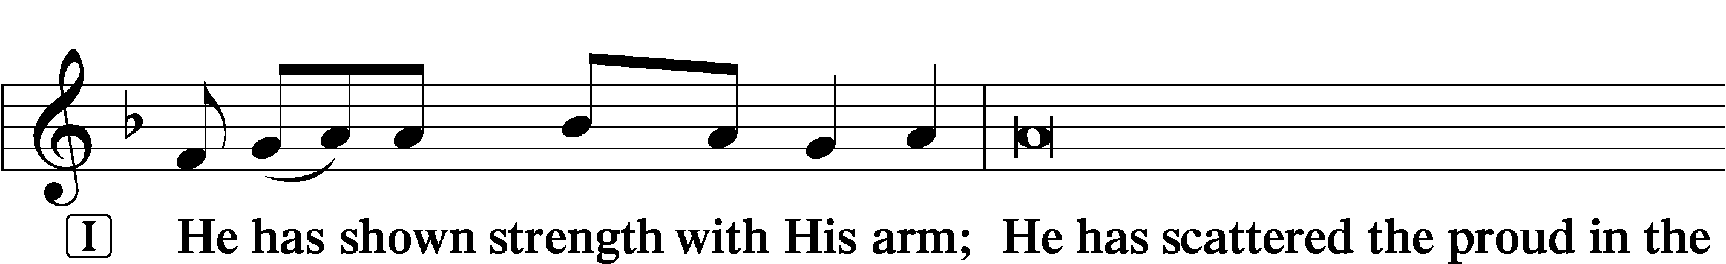

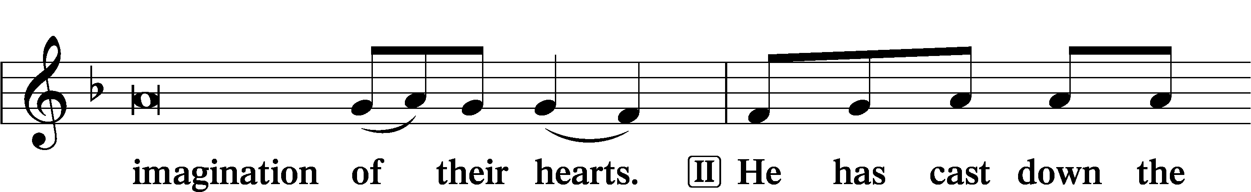

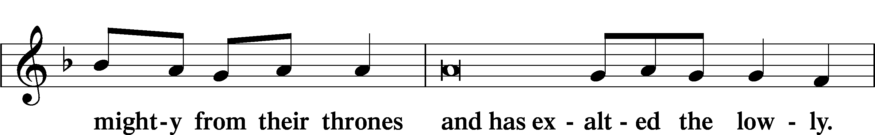

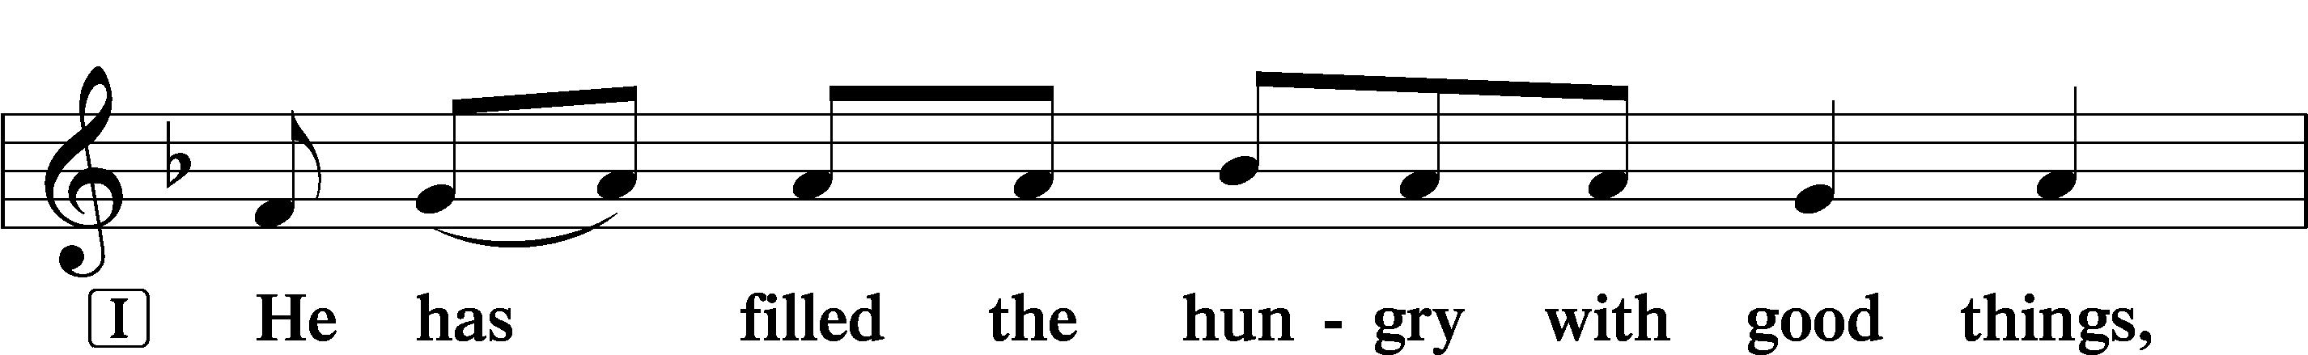

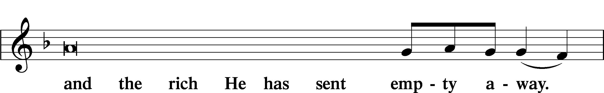

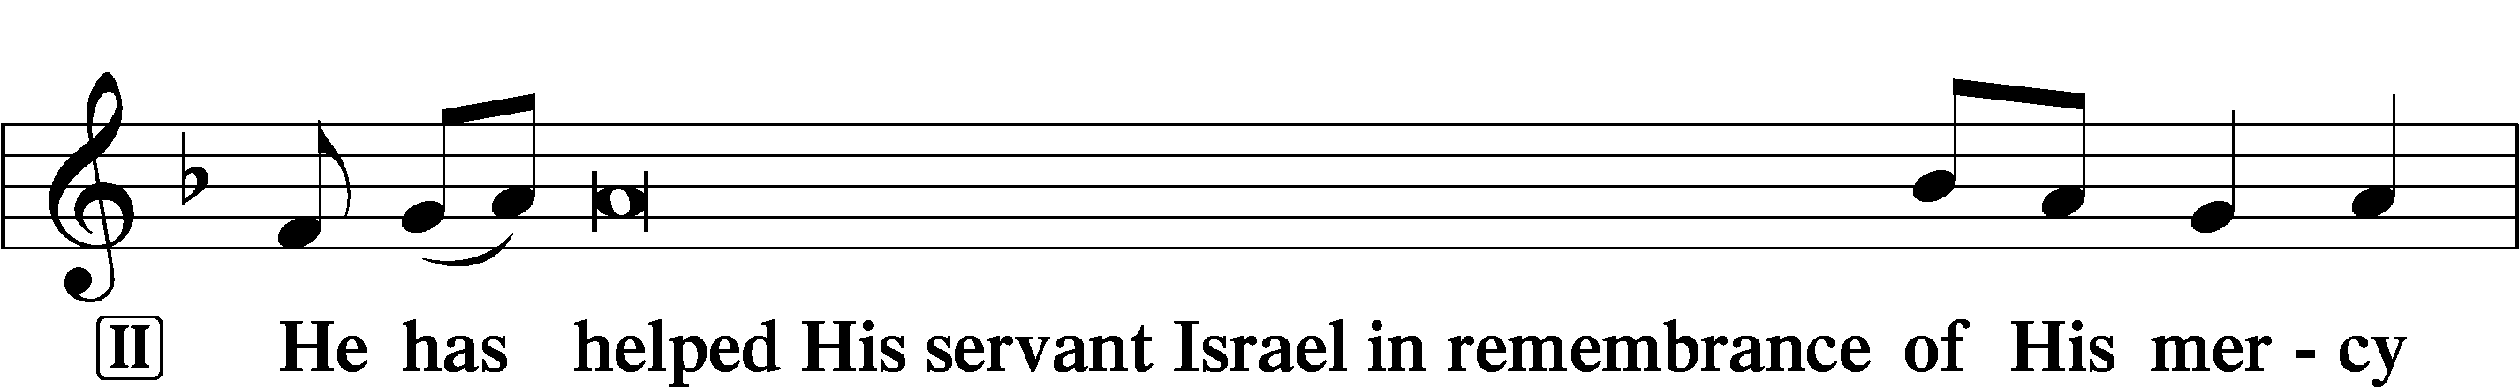

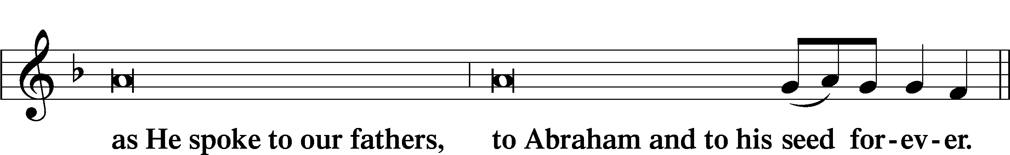

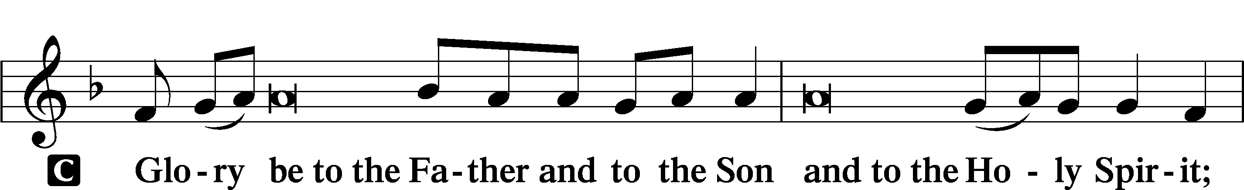

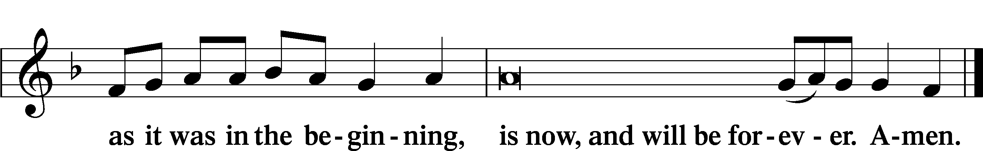

Offering

# Prayer

Kyrie LSB 233

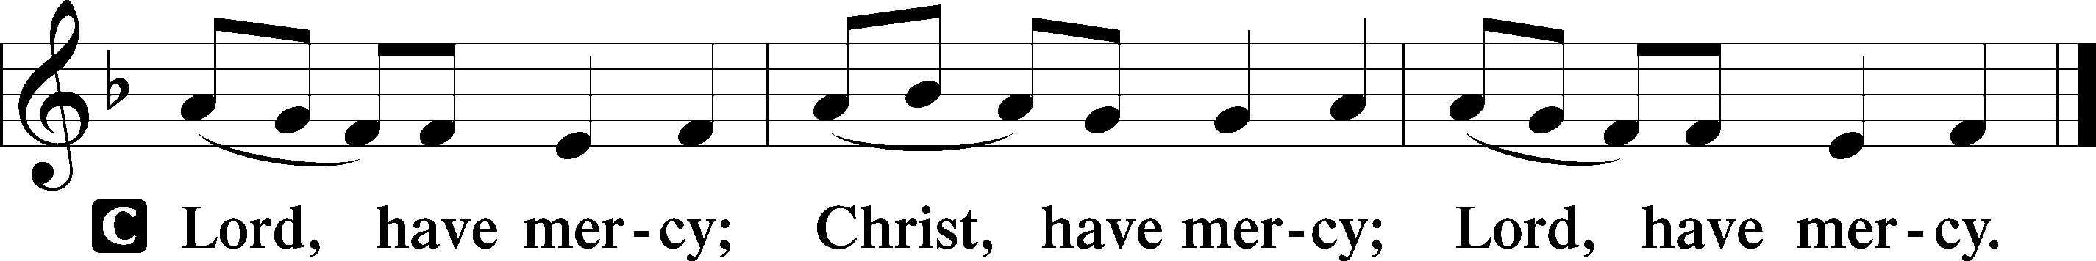

Lord’s Prayer

C **Our Father who art in heaven,**

**hallowed be Thy name,**

**Thy kingdom come,**

**Thy will be done on earth**

**as it is in heaven;**

**give us this day our daily bread;**

**and forgive us our trespasses**

**as we forgive those**

**who trespass against us;**

**and lead us not into temptation,**

**but deliver us from evil.**

**For Thine is the kingdom**

**and the power and the glory**

**forever and ever. Amen.**

Collects

P O Lord, hear my prayer.

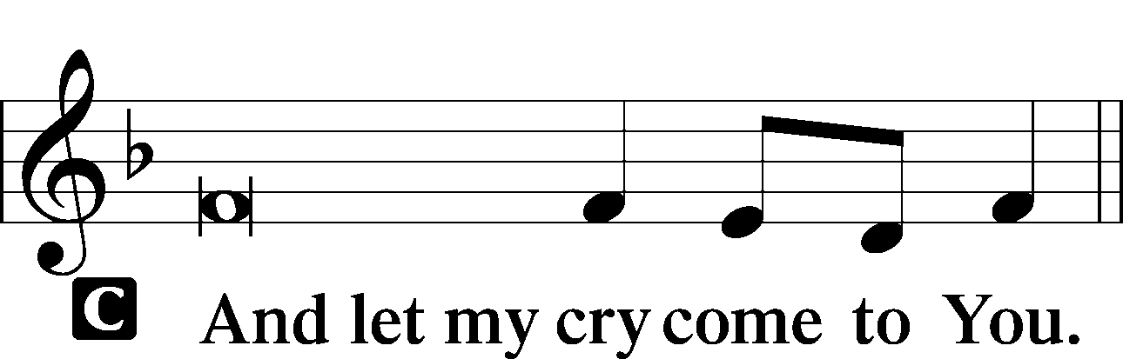

P Let us pray.  
Heavenly Father, all things are in Your hands, both creation and our very lives. Turn our eyes to follow the finger of John the Baptist pointing to Jesus, the Lamb of God who takes away the sins of the world. Jesus has received nails into His hands for our sins to bring us forgiveness. When and where You will, use us to point others to Jesus and where He promises to be found in His Word and Sacraments; through Jesus Christ, our Lord.

C **Amen.**

P Almighty God, by Your great goodness mercifully look upon Your people that we may be governed and preserved evermore in body and soul; through Jesus Christ, our Lord.

C **Amen.**

P Almighty and everlasting God, You despise nothing You have made and forgive the sins of all who are penitent. Create in us new and contrite hearts that lamenting our sins and acknowledging our wretchedness we may receive from You full pardon and forgiveness; through Jesus Christ, our Lord.

C **Amen.**

C **I thank You, my heavenly Father, through Jesus Christ, Your dear Son, that You have graciously kept me this day; and I pray that You would forgive me all my sins where I have done wrong, and graciously keep me this night. For into Your hands I commend myself, my body and soul, and all things. Let Your holy angel be with me, that the evil foe may have no power over me.**

**Amen.**

P O God, from whom come all holy desires, all good counsels, and all just works, give to us, Your servants, that peace which the world cannot give, that our hearts may be set to obey Your commandments and also that we, being defended from the fear of our enemies, may live in peace and quietness; through Jesus Christ, Your Son, our Lord, who lives and reigns with You and the Holy Spirit, one God, now and forever.

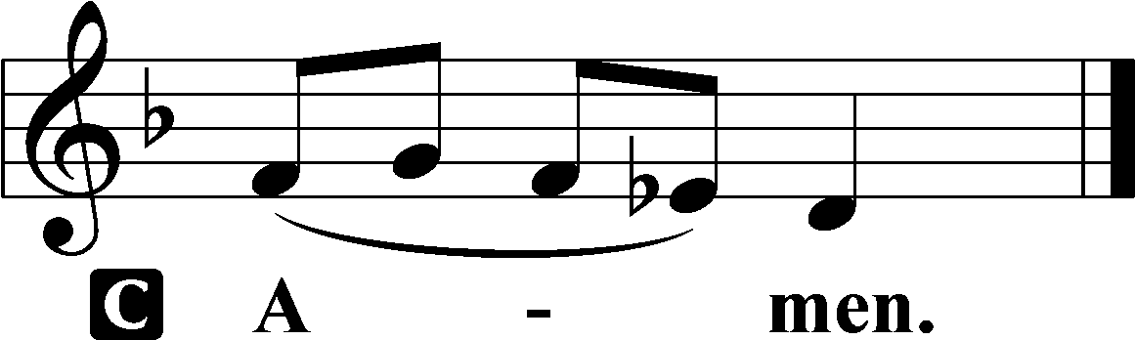

Benedicamus LSB 234

P Let us bless the Lord.

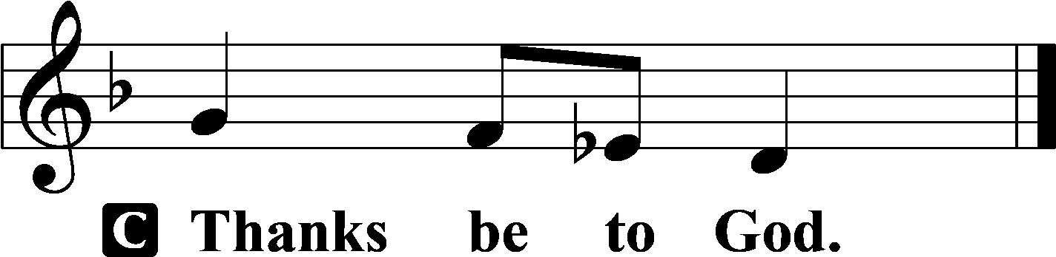

Benediction LSB 234

P The grace of our Lord T Jesus Christ and the love of God and the communion of the Holy Spirit be with you all.



954 We All Believe in One True God

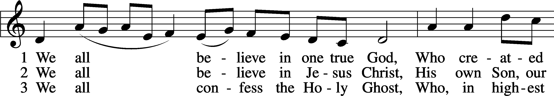

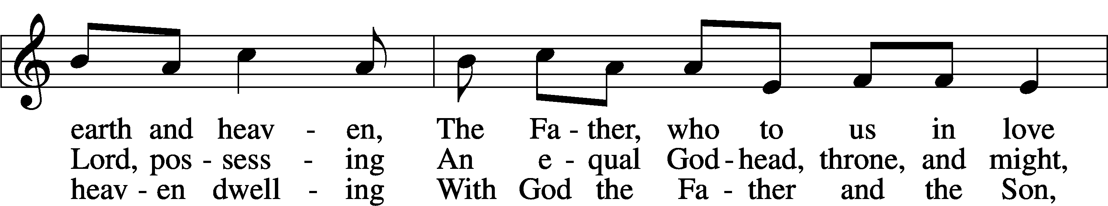

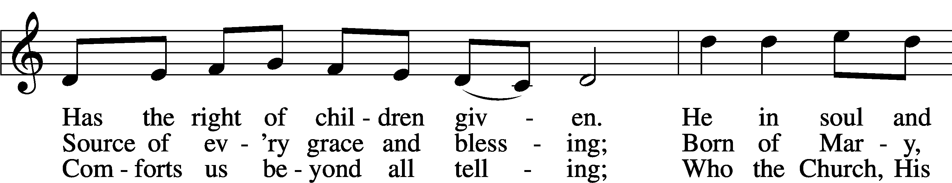

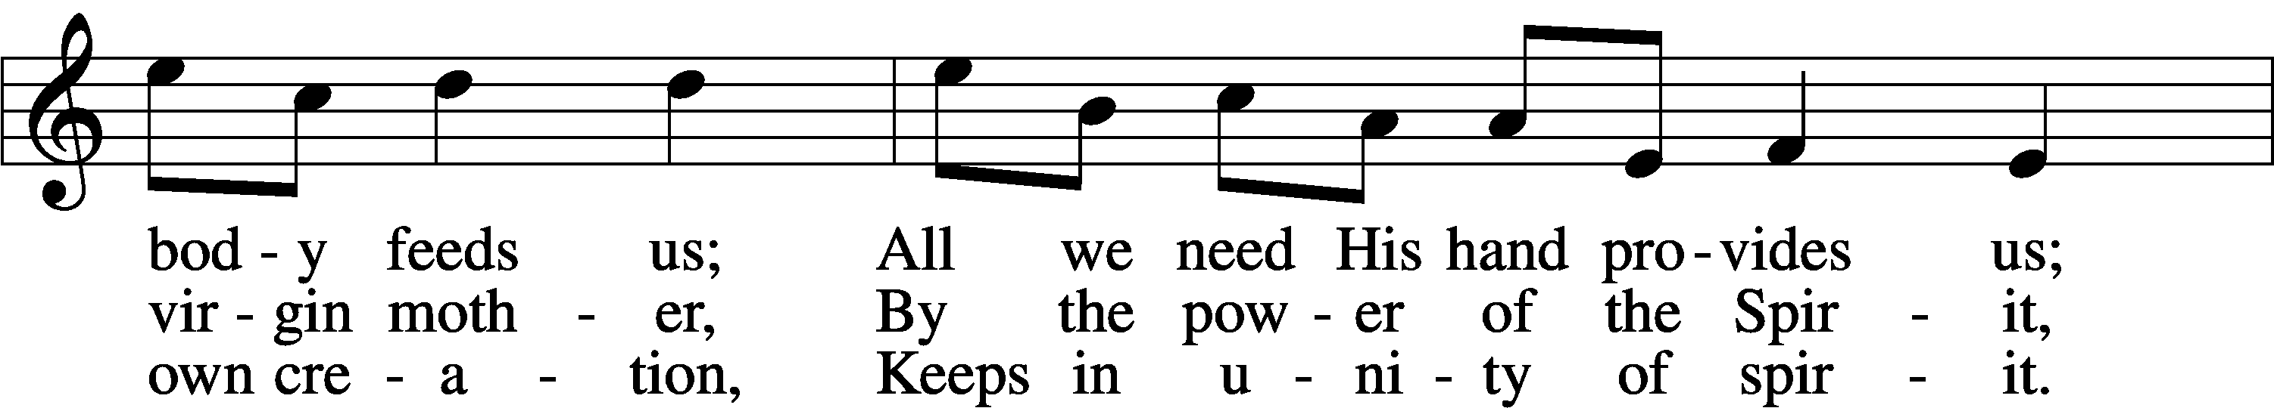

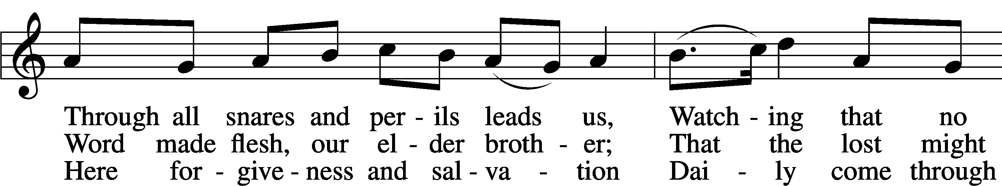

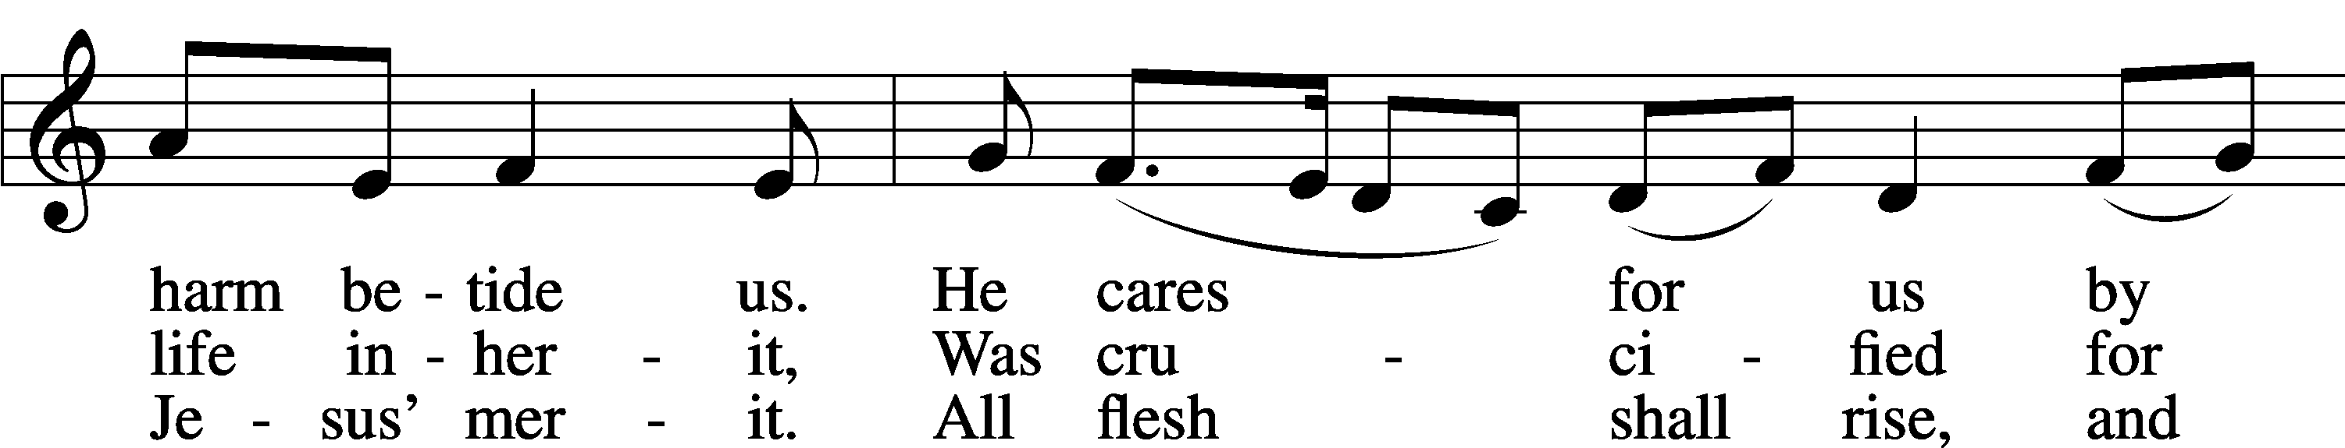

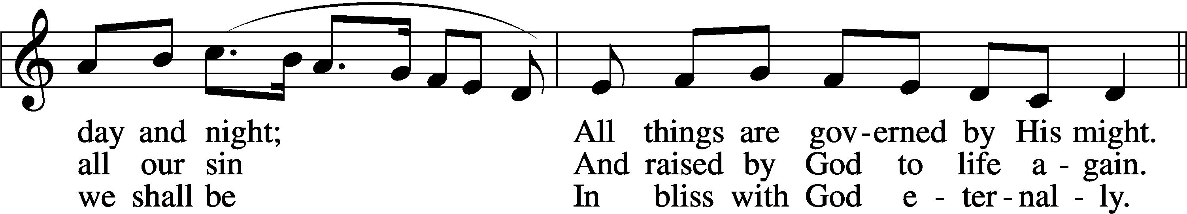

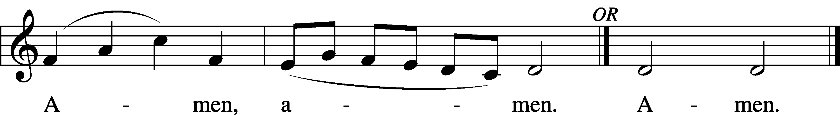

Text: Martin Luther, 1483–1546; tr. The Lutheran Hymnal, 1941, alt.  
Tune: Latin, 14th cent., adapt.  
Text and tune: Public domain

Acknowledgments

Unless otherwise indicated, Scripture quotations are from the ESV® Bible (The Holy Bible, English Standard Version®), copyright © 2001 by Crossway, a publishing ministry of Good News Publishers. Used by permission. All rights reserved.

Created by Lutheran Service Builder © 2025 Concordia Publishing House.